**Power BI Dashboard for SN Corporation**

**Problem Statement** :

As an employee of SN Corporation, You have an important meeting this Monday. Your promotion is 1 step away & this meeting can either get you a big raise & a bigger job title OR keep you stuck in your current role for 2 more years. Extract & present actionable insights for your company.

Dashboard:

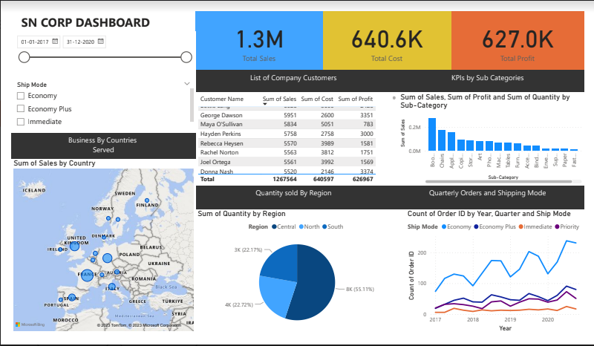

Steps to build the above Dashboard:

Step1 : 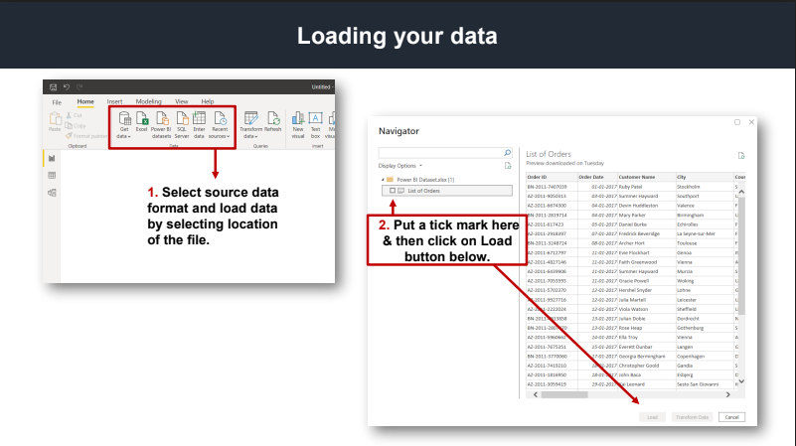

Step 2 : 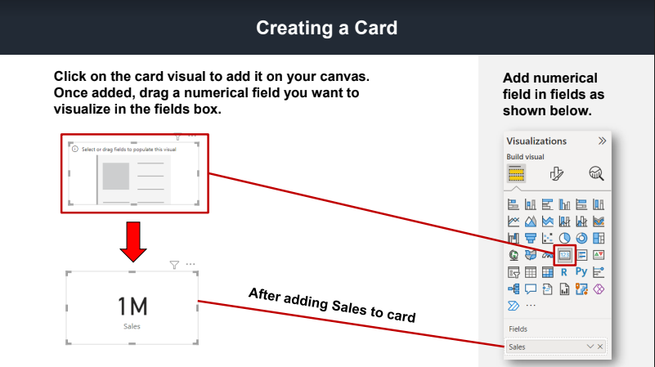

Step 3: 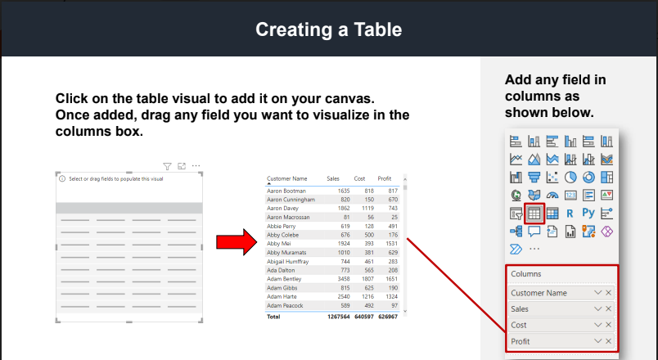

Step 4:

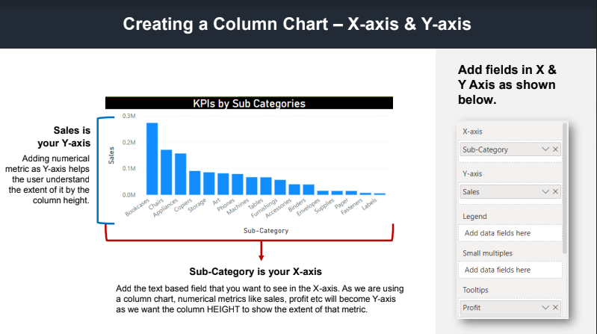

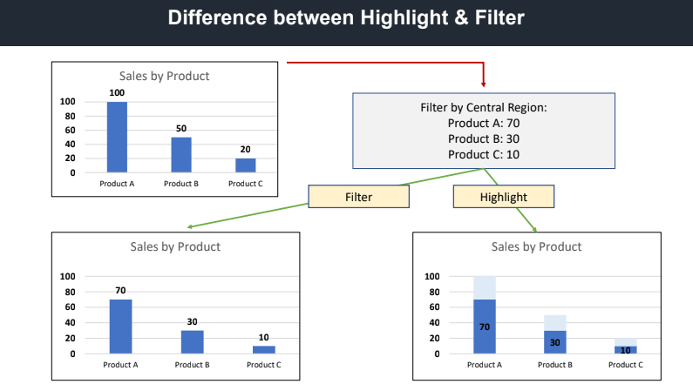

Step 5:

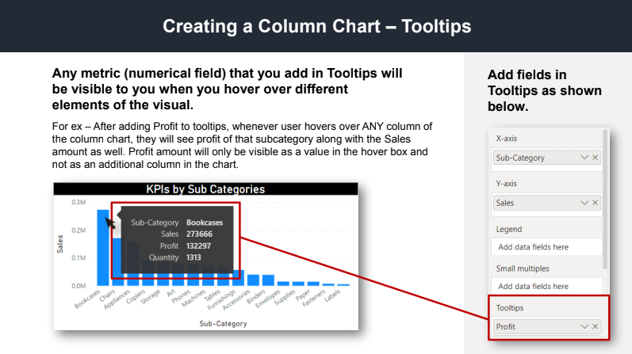

Step 6:

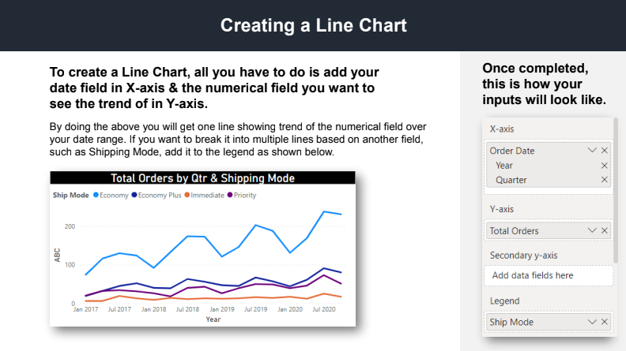

Step 7 : 